CSS-HTML Exam —-4bhrs

1. Design a form with input fields for name, email, and message.

**Ans:** <!DOCTYPE html>

<html lang="en">

<head>

    <meta charset="UTF-8">

    <meta name="viewport" content="width=device-width, initial-scale=1.0">

    <title>Contact Form</title>

</head>

<body>

    <h1>Contact Us</h1>

    <form action="/submit" method="post">

        <label for="name">Name:</label>

        <input type="text" id="name" name="name" required>

        <br>

        <label for="email">Email:</label>

        <input type="email" id="email" name="email" required>

        <br>

        <label for="message">Message:</label><br>

        <textarea id="message" name="message" rows="5" required></textarea>

        <br><br>

        <input type="submit" value="Submit">

    </form>

</body>

</html>

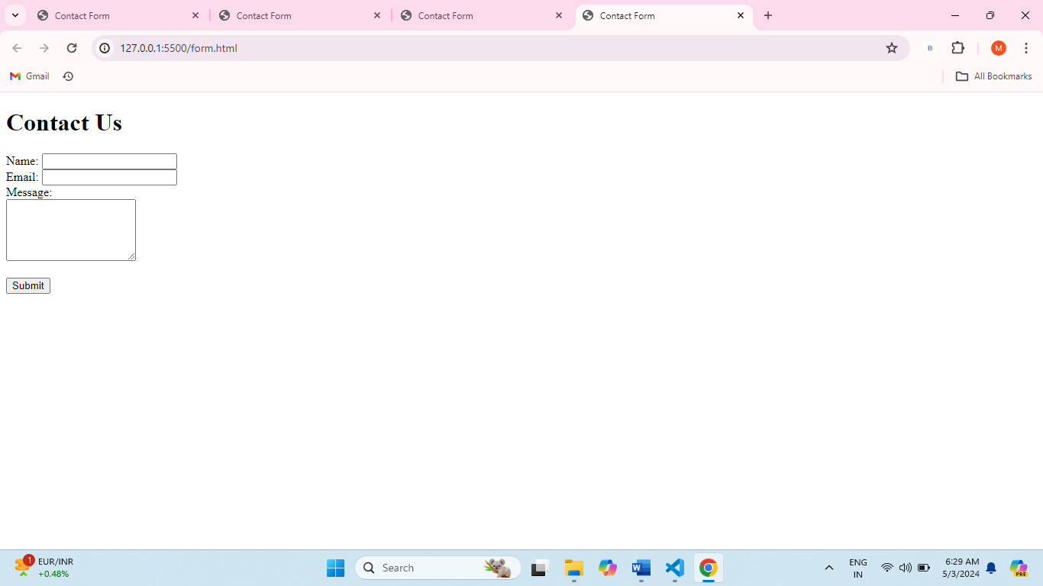

1. Create a three-column layout using CSS grid or flexbox.
2. <!DOCTYPE html>
3. <html lang="en">
4. <head>
5. <meta charset="UTF-8">
6. <meta name="viewport" content="width=device-width, initial-scale=1.0">
7. <style>
8. .container {
9. display: grid;
10. grid-template-columns: repeat(3, 1fr);
11. gap: 20px;
12. display: flex;
13. justify-content: center;
14. }
15. .column {
16. padding: 10px;
17. border: 1px solid #ddd;
18. flex-direction: column;
19. height: 200px;
20. width: 100px;
21. border: 1px black solid;
23. }
24. #c1{
25. background-color: rgb(19, 46, 58);
26. }
27. #c2{
28. background-color: rgb(54, 60, 61);
29. }
30. #c3{
31. background-color:rgb(7, 20, 31)
32. }
33. </style>
34. </head>
35. <body>
36. <div class="container">
37. <div class="column"id="c1">Column 1</div>
38. <div class="column" id="c2">Column 2</div>
39. <div class="column" id="c3">Column 3</div>
40. </div>
41. </body>
42. </html>

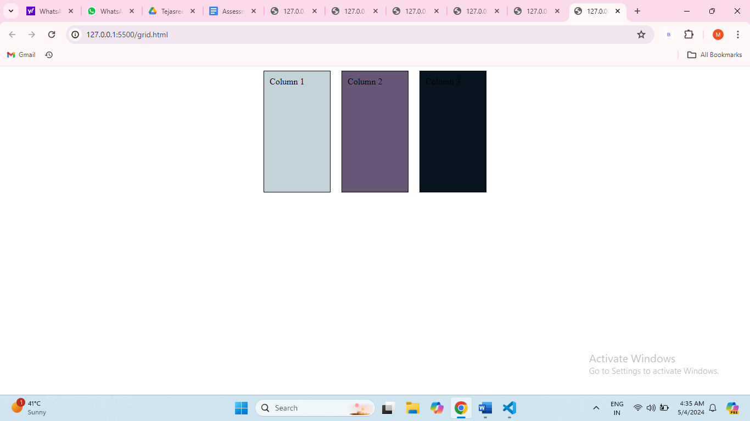

3.Make a responsive website that adjusts its layout for different screen sizes.

<!DOCTYPE html>

<html lang="en">

<head>

    <meta charset="UTF-8">

    <meta name="viewport" content="width=device-width, initial-scale=1.0">

    <title>Document</title>

</head>

<body>

</body>

</html>

    <div class="container">

   <div class="navbar">

       <a href="#" class="logo"></a>

       <ul>

   <li><a href="#">Home</a></li>

   <li><a href="#">About us</a></li>

   <li><a href="#">Contact us</a></li>

       </ul>

   </div>

   <div class="content">

       <h1>GREEMUS TECHNOLOGY.</h1><br>

       <h2>Full Stack Mern Development</h2>

   <style>

    *{

    margin:0;

    padding:0;

    font-family: sans-serif;

}

.container{

    width: 100%;

    height: 100vh;

    background-image: linear-gradient(rgba(31, 31, 31, 0),rgba(31,31,31,0)),url(https://tse2.mm.bing.net/th?id=OIP._mFlZKl2bKyALMeIinPUxgHaEK&pid=Api&P=0&h=220);

    background-size: cover;

    background-position: center;

}

.navbar{

    width: 50%;

    margin: auto;

    padding: 30px 0;

    display: flex;

    align-items: center;

    justify-content: space-between;

    position: relative;

}

.logo{

    font-size: medium;

    font-weight: bolder;

    cursor: pointer;

    text-decoration: none;

    color: rgb(6, 75, 87);

}

.navbar ul li{

    list-style: none;

    display:inline-block;

    margin: 0 20px;

    position:relative;

}

.navbar ul li a{

    text-decoration: dotted;

    color: teal;

    font-weight: bolder;

    font-style: oblique;

}

.content{

    width:100%;

    color:rgb(14, 6, 6);

    position: absolute;

    top: 50%;

    text-align: center;

    transform: translateY(-50%);

    font: italic;

}

    @media (max-width: 768px) {

      }

      @media (min-width: 769px) {

      }

   </style>

   </div>

    </div>

</body>

</html>

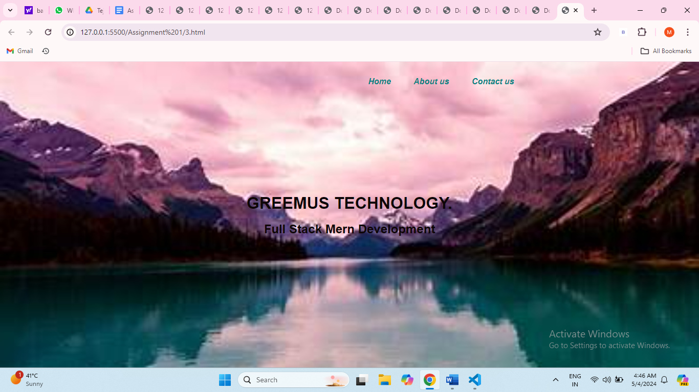

1. Style a button to change its appearance when hovered over.
2. <!DOCTYPE html>
3. <html lang="en">
4. <head>
5. <meta charset="UTF-8">
6. <meta name="viewport" content="width=device-width, initial-scale=1.0">
7. <title>Document</title>
8. </head>
9. <body>
10. <style>.my-button {
11. background-color: #aa0481;
12. color: white;
13. padding: 10px 20px;
14. border: none;
15. border-radius: 4px;
16. transition: background-color 0.4s;
17. }
19. .my-button:hover {
20. background-color: #00ba1f;
21. cursor: pointer;
22. }
23. </style>
24. <button class="my-button">Hover Me</button>
25. </body>
26. </html>

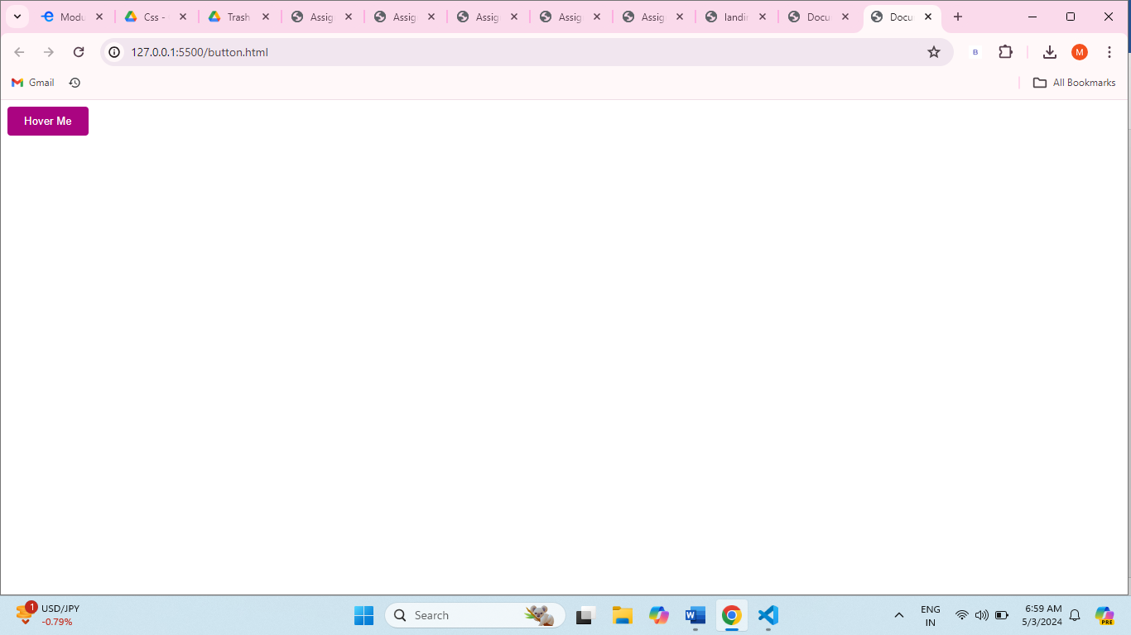

1. Create a dropdown menu using HTML and CSS.
2. <!DOCTYPE html>
3. <html lang="en">
4. <head>
5. <meta charset="UTF-8">
6. <meta name="viewport" content="width=device-width, initial-scale=1.0">
7. <title>Document</title>
8. </head>
9. <body>
11. <h2>Drop-down menu:</h2>
12. <div id="list">
13. <label for="dropdown" id="menu">Choose Language:</label>
14. <select>
15. <style>
16. body{
17. padding: 20px;
18. text-align: center;
19. box-sizing: border-box;
20. background-color: lightblue;
21. border: 2px black solid;
22. height: 300px;
23. width: 300px;
24. }
26. </style>
27. <option id="o"></option>
28. <option id="r">Reactjs</option>
29. <option id="p">Python</option>
30. <option id="a">.net</option>
31. <option id="s">SAP</option>
32. <option id="j">Java</option>
33. </select>
34. </div>
35. </body>
36. </html>

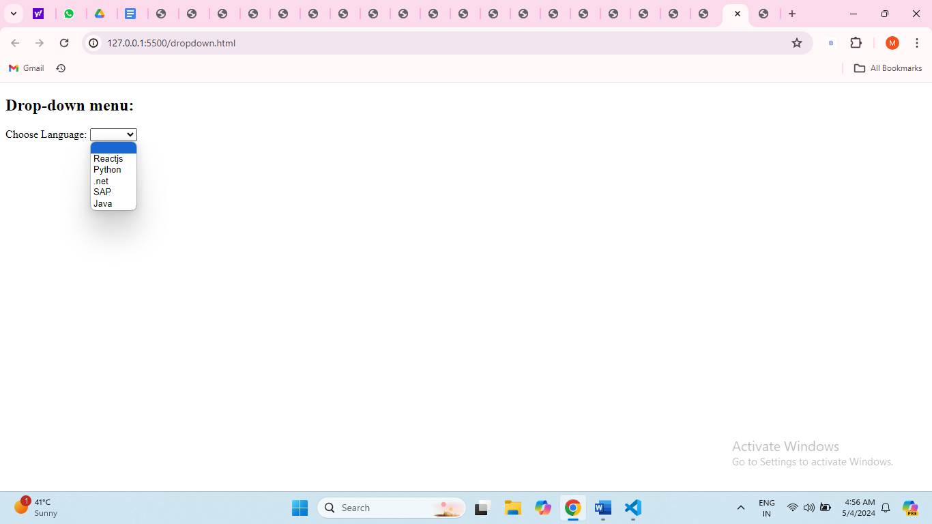

1. Build a simple slideshow using HTML, CSS, and JavaScript.
2. Design a pricing table with multiple plans using HTML and CSS.
3. <!DOCTYPE html>
4. <html lang="en">
5. <head>
6. <meta charset="UTF-8">
7. <meta name="viewport" content="width=device-width, initial-scale=1.0">
8. <title>Document</title>
9. </head>
10. <body>
11. <style>
12. body{
13. background-color:ivory;
14. }
16. h2{
17. color:red;
18. background-color: black;
19. }
21. table{
22. padding: 10px;
23. text-align: center;
24. height: 400px;
25. width: 500px;
26. background-color: black;
27. color: rgb(96, 11, 182);
28. border:rgb(211, 68, 43) 1px solid
30. }
31. </style>
32. <h2 align="center"></h2>
33. <table  border="2" cellpadding="4" cellspacing="4" align="center" style="border-collapse: collapse; ">
34. <tr>
35. <th>Features</th>
36. <th>Basic</th>
37. <th>Standard</th>
38. <th>Premium</th>
39. </tr>
40. <tr>
41. <td>Monthly Price</td>
42. <th>199</th>
43. <th>499</th>
44. <th>649</th>
45. </tr>
46. <tr>
47. <td>HD Available</td>
48. <td>No</td>
49. <td>Yes</td>
50. <td>Yes</td>
51. </tr>
52. <tr>
53. <td>UltraHD Available</td>
54. <td>No</td>
55. <td>No</td>
56. <td>Yes</td>
57. </tr>
58. <tr>
59. <td>Screen Limit</td>
60. <td>1</td>
61. <td>2</td>
62. <td>4</td>
63. </tr>
64. </table>
65. </body>
66. </html>

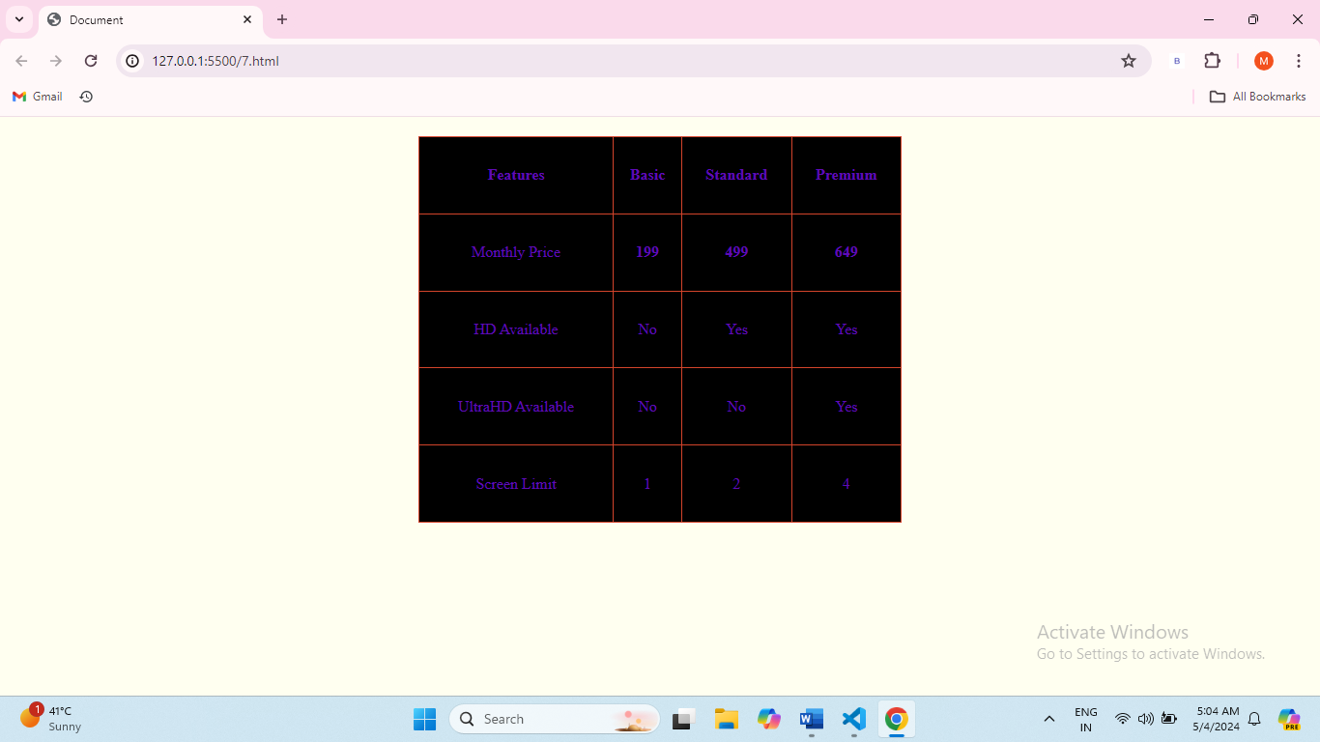

1. Make a sticky navigation bar that stays at the top of the page when scrolling.
2. <body>
3. <style> *{
4. padding: 0px;
5. margin: 5px;
6. background-color:rgb(204, 169, 199);
7. }
8. .container{
9. width: 100%;
10. height: 100vh;
11. background-position: center;
12. background-size: cover;
13. }
14. .navbar{
15. display:flex;
16. background-color: rgb(228, 237, 241);
17. align-items: center;
18. justify-content: space-between;
19. position: fixed;
20. width:100%;
21. margin:auto;
22. }
23. .navbar ul li{
24. list-style: none;
25. display: inline-block;
26. margin: 0 20px;
27. position: relative;
28. color: black;
30. }
31. #content{
33. padding: 50px;
34. align-content: center;
35. }
36. </style>
37. <div class="container">
38. <div class="navbar">
39. <a href="#welcome"><h2>GREEMUS TECHNOLOGY</h2></a>
40. <ul>
41. <li><a href="#menu">Menu</a></li>
43. <li><a href="#about">About</a></li>
44. <li><a href="#contact">Contact</a></li>
46. </ul>
47. </div>
48. <div id="content">
49. <h3>About</h3>
50. Lorem ipsum dolor sit amet consectetur adipisicing elit. Sequi sed illo officia perferendis, eaque dolores. Laudantium a perferendis quisquam necessitatibus sequi? Molestiae facilis doloribus minus odio tempore velit vitae obcaecati commodi iusto deserunt? Nemo totam sequi soluta! Dicta explicabo dolore cum laborum maiores placeat voluptate unde ratione? Sed, beatae optio?
51. </div>
52. </div>
53. </body>
54. </html>

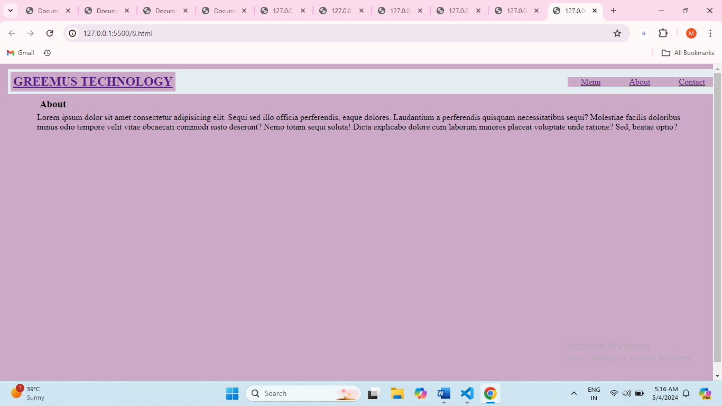

1. Implement a hover effect on images that enlarges them slightly.
2. <html><body><style>
3. img{
5. width:300px;
6. height: 300px;
7. }
8. img:hover{
9. transform: scale(1.1);
10. border: black 4px solid;
11. box-shadow: 2px;
12. }
13. </style>
14. <img src="https://www.pixelstalk.net/wp-content/uploads/2016/06/Free-Images-Wallpaper-HD-Background.jpg"><br>
16. <img src="https://tse2.mm.bing.net/th?id=OIP.Ts9ND_n-CX5udyClmuhfCAHaLG&pid=Api&P=0&h=220">
17. </body>
18. </html>

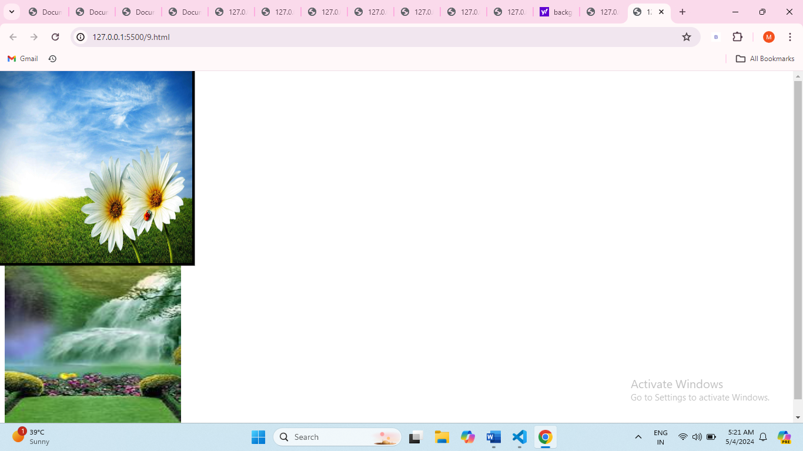

1. Create a login form with HTML and style it using CSS.
2. <body>
3. <style>
4. *{
5. margin: 0;
6. padding: 0;
7. box-sizing: border-box;
8. }
9. body{
10. justify-content: center;
11. align-items: center;
12. display: flex;
13. background-color: rgb(20, 22, 20);
14. height: 100vh;
15. }
16. #form{
18. width: 350px;
19. background-color: azure;
20. border: 1px solid rgb(15, 124, 15);
21. display: flex;
22. flex-direction: column;
23. align-items: center;
24. border-radius: 7px;
25. padding: 20px;
26. gap: 10px;
27. }
28. .f1 {
29. display: flex;
30. flex-direction: column;
31. width: 100%;
32. }
33. .f1 input {
34. width:100%;
35. outline:none;
36. border: 1px grey solid;
37. border-radius: 3px;
38. padding: 10px;
39. }
40. button{
41. width: 100%;
42. background-color: rgb(77, 28, 168);
43. border-radius: 3px;
44. padding: 7px;
45. margin: 10px;
46. outline: none;
47. border: none;
48. opacity: 0.7;
49. }
50. #img{
51. width:50px;
52. }
53. </style>
54. <div id="form">
55. <h4>welcome</h4>
56. <img id="img" src="https://tse4.mm.bing.net/th?id=OIP.i18S5hbENZf5sBwYOMm7UAHaHa&pid=Api&P=0&h=220">
57. <div class="f1"><label>Username:</label>
58. <input type="text"></div>
59. <div class="f1"><label>Password:</label>
60. <input type="password"></div>
61. <button>Submit</button>
62. </div>
63. </body>
64. </html>

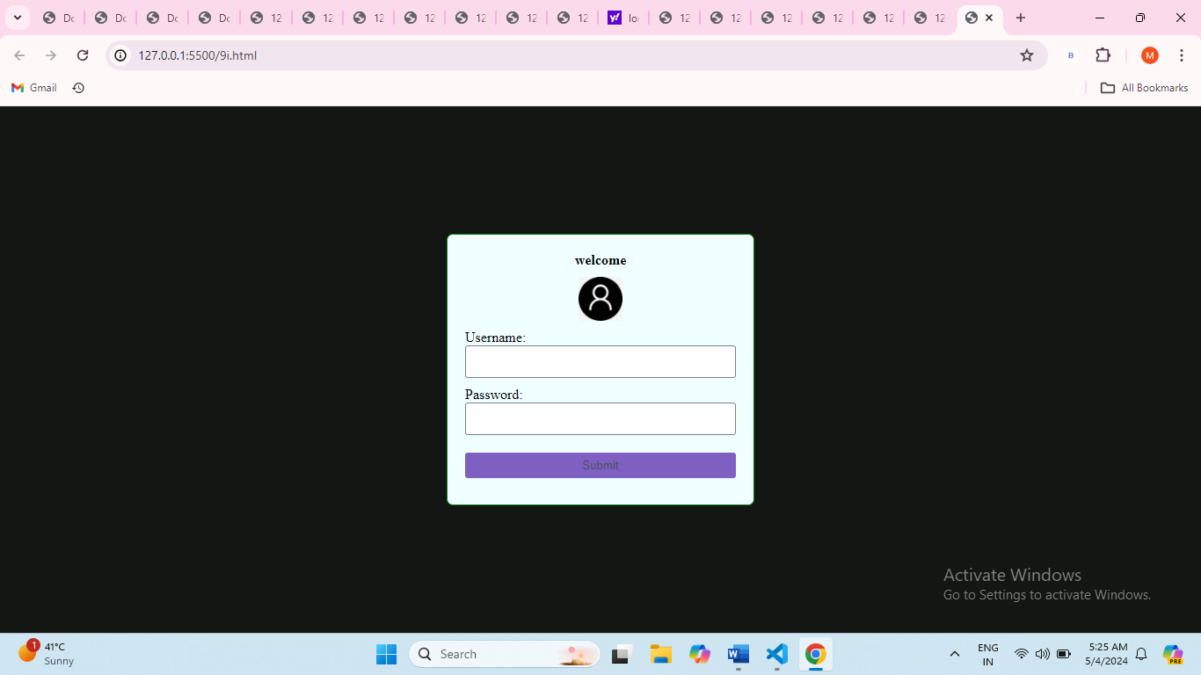

1. Build a responsive gallery that displays images in a grid format.
2. <body>
3. <style>
4. .row {
5. display: flex;
6. flex-wrap: wrap;
7. padding: 0 4px;
8. }
9. .column {
10. flex: 25%;
11. max-width: 25%;
12. padding: 0 4px;
13. }
14. .column img {
15. margin-top: 8px;
16. vertical-align: middle;
17. width: 100%;
18. }
19. @media screen and (max-width: 800px) {
20. .column {
21. flex: 50%;
22. max-width: 50%;
23. }
24. }
25. @media screen and (max-width: 600px) {
26. .column {
27. flex: 100%;
28. max-width: 100%;
29. }
30. }
31. </style>
32. <div class="row">
33. <div class="column">
34. <img src="https://up.yimg.com/ib/th?id=OIP.Vs9TdQkcRwigX7qb1_LA7gHaFK&pid=Api&rs=1&c=1&qlt=95&w=143&h=99" alt="Image 1">
35. <img src="https://up.yimg.com/ib/th?id=OIP.UjoIEjVgM7WA-9mrImZ9BwHaEo&pid=Api&rs=1&c=1&qlt=95&w=182&h=114" alt="Image 2">
36. <img src="https://up.yimg.com/ib/th?id=OIP.9ZG9zoOPiqXA-375GMYbUgHaFj&pid=Api&rs=1&c=1&qlt=95&w=135&h=101" alt="Image 3">
37. <img src="https://tse3.mm.bing.net/th?id=OIP.0VnQpgZYrZNjVk9O_QnICQHaFj&pid=Api&P=0&h=220" alt="Image 4">
38. <img src="https://tse4.mm.bing.net/th?id=OIP.QuGUN-dYmgtLuJ5ufWlQAAAAAA&pid=Api&P=0&h=220" alt="Image 5">
39. <img src="https://up.yimg.com/ib/th?id=OIP.Vs9TdQkcRwigX7qb1_LA7gHaFK&pid=Api&rs=1&c=1&qlt=95&w=143&h=99" alt="Image 1">
40. </div>
41. <div class="column">
42. <img src="https://up.yimg.com/ib/th?id=OIP.dRuKDB6bXUoZ_Y9JO_sIIAHaFj&pid=Api&rs=1&c=1&qlt=95&w=152&h=114" alt="Image 6">
43. <img src="https://up.yimg.com/ib/th?id=OIP.phEDfgJViJ7EcoccTol8kQHaEq&pid=Api&rs=1&c=1&qlt=95&w=181&h=114" alt="Image 7">
45. </div>
47. </div>
49. </body>

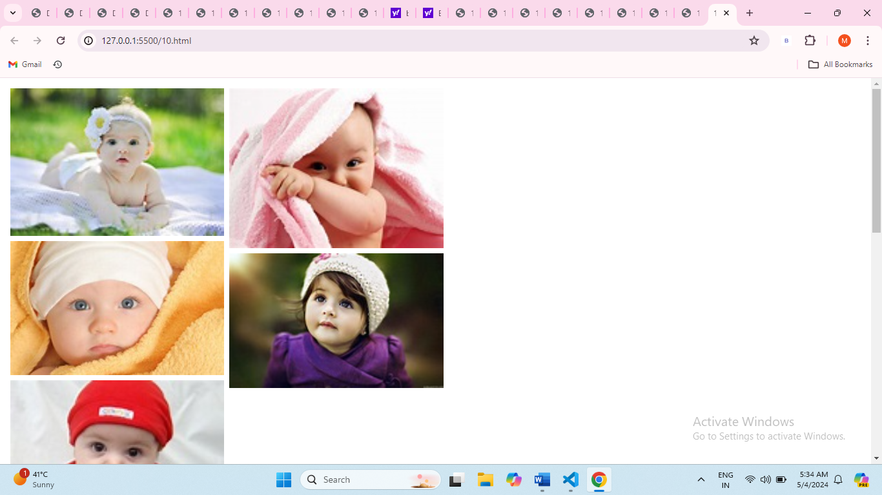

1. Style text to have different fonts, sizes, and colors on the same page.
2. <body>
3. <style>#f1{
4. font-family: 'Franklin Gothic Medium', 'Arial Narrow', Arial, sans-serif;
5. color: rgb(116, 44, 62);
6. }
7. #f2{
8. font-family:'Gill Sans', 'Gill Sans MT', Calibri, 'Trebuchet MS', sans-serif;
9. color:blueviolet;
10. }
11. #f3{
12. font-family:'Trebuchet MS', 'Lucida Sans Unicode', 'Lucida Grande', 'Lucida Sans', Arial, sans-serif;
13. color:darkgoldenrod
14. }
15. #f4{
16. font-family: Impact, Haettenschweiler, 'Arial Narrow Bold', sans-serif;
17. color:brown
18. }
19. #f5{
20. font-family: Cambria, Cochin, Georgia, Times, 'Times New Roman', serif;
21. color: aquamarine;
22. }
23. #f6{
24. font-family: Verdana, Geneva, Tahoma, sans-serif;
25. color:teal
26. }
27. </style>
28. <h1 id="f1">"GREEMUS TECHNOLOGY"</h2>
29. <h2 id="f2">"GREEMUS TECHNOLOGY"</h2>
30. <h3 id="f3">"GREEMUS TECHNOLOGY"</h2>
31. <h4 id="f4">"GREEMUS TECHNOLOGY"</h2>
32. <h5 id="f5">"GREEMUS TECHNOLOGY"</h2>
33. <h6 id="f6">"GREEMUS TECHNOLOGY"</h2>
34. </body>
35. </html>

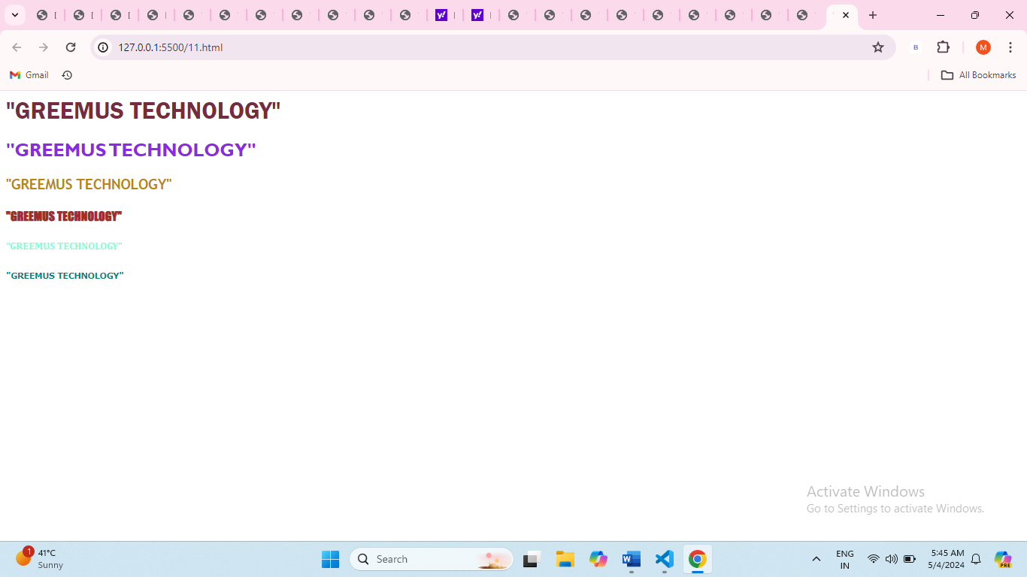

1. Design a footer that stays at the bottom of the page, regardless of content height.
2. <body>
3. <style>
4. html, body {
5. height: 100%;
6. margin: 0;
7. padding: 0;
8. }
9. body {
10. display: flex;
11. flex-direction: column;
12. }
13. .content {
14. flex: 1;
15. }
16. footer {
17. background-color: #9bd0f3;
18. color: rgb(15, 18, 19);
19. text-align: center;
20. padding: 10px;
21. }
22. </style>
23. <div class="content">
24. Lorem ipsum dolor sit amet, consectetur adipiscing elit, sed do eiusmod tempor incididunt ut labore et dolore magna aliqua. Ut enim ad minim veniam, quis nostrud exercitation ullamco laboris nisi ut aliquip ex ea commodo consequat. Duis aute irure dolor in reprehenderit in voluptate velit esse cillum dolore eu fugiat nulla pariatur. Excepteur sint occaecat cupidatat non proident, sunt in culpa qui officia deserunt mollit anim id est laborum.
25. </div>
26. <footer>
27. Private policy Terms and conditions
28. </footer>
29. </body>

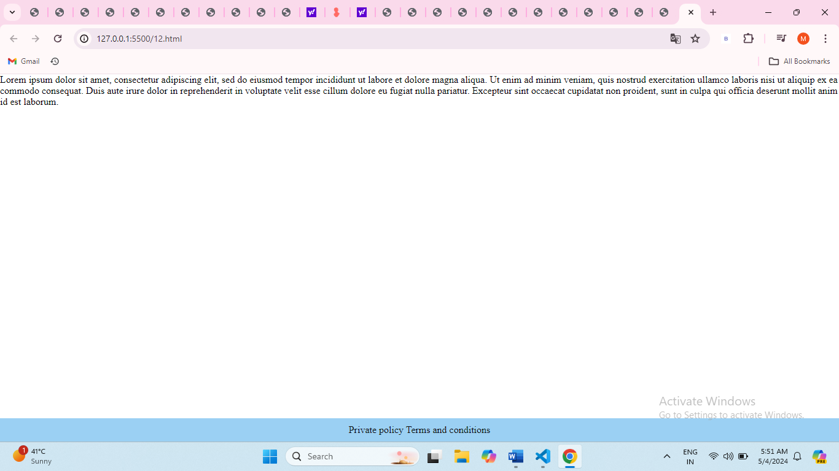

1. Make a horizontal scrolling website using CSS overflow property.
2. <style>.horizontal-scroll-container {
3. overflow-x: auto;
4. white-space: nowrap;
5. }
6. </style>
7. <div class="horizontal-scroll-container">
8. Lorem ipsum dolor sit amet, consectetur adipiscing elit, sed do eiusmod tempor incididunt ut labore et dolore magna aliqua. Ut enim ad minim veniam, quis nostrud exercitation ullamco laboris nisi ut aliquip ex ea commodo consequat. Duis aute irure dolor in reprehenderit in voluptate velit esse cillum dolore eu fugiat nulla pariatur. Excepteur sint occaecat cupidatat non proident, sunt in culpa qui officia deserunt mollit anim id est laborum.
9. </div>

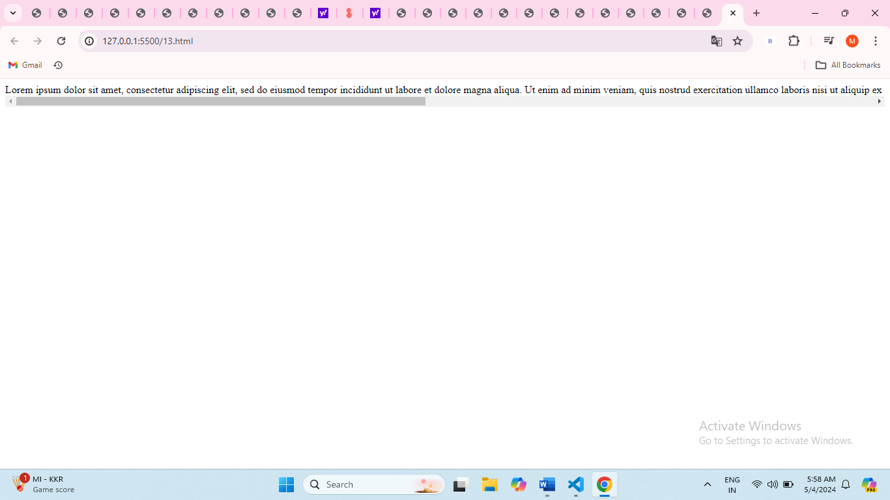

1. Create a progress bar using HTML and CSS.
2. <body>
3. <style>
5. #container{
6. display: flex;
7. align-content: center;
8. height: 450px;
9. width:400px;
11. }
12. #parent{
13. padding:10px;
14. margin: 10px;
15. text-align: center;
16. }
17. #d1{
18. width: 350px;
19. height: 30px;
20. border: 2px black solid;
21. background-color: rgb(78, 13, 139);
22. }
23. #d2{
24. width: 330px;
25. height: 30px;
26. border: 2px black solid;
27. background-color: darkcyan;
28. }
29. #d3{
30. width: 340px;
31. height: 30px;
32. border: 2px black solid;
33. background-color: rgb(201, 5, 5);
34. }
35. #d4{
36. width: 300px;
37. height: 30px;
38. border: 2px black solid;
39. background-color:rgb(177, 29, 110);
40. }
41. #d5{
42. width: 290px;
43. height: 30px;
44. border: 2px black solid;
45. background-color:turquoise;
46. }
47. #d6{
48. width: 200px;
49. height: 30px;
50. border: 2px black solid;
51. background-color:steelblue;
52. }
53. #d7{
54. width: 290px;
55. height: 30px;
56. border: 2px black solid;
57. background-color:rgb(94, 173, 94);
58. }
60. </style>
61. <div id="container">
62. <div id="parent" >
63. <div id="d1">Html 100%</div><br>
64. <div id="d2">CSS 90%</div><br>
65. <div id="d3">JavaScript 80%</div><br>
66. <div id="d4">Nodejs 70%</div><br>
67. <div id="d5">Reactjs 60%</div><br>
68. <div id="d6">MongoDB 50%</div><br>
69. <div id="d7">Sql 40%</div><br>
70. <div>
71. </div>
72. </div>
73. </div>
75. </body>
76. </html>

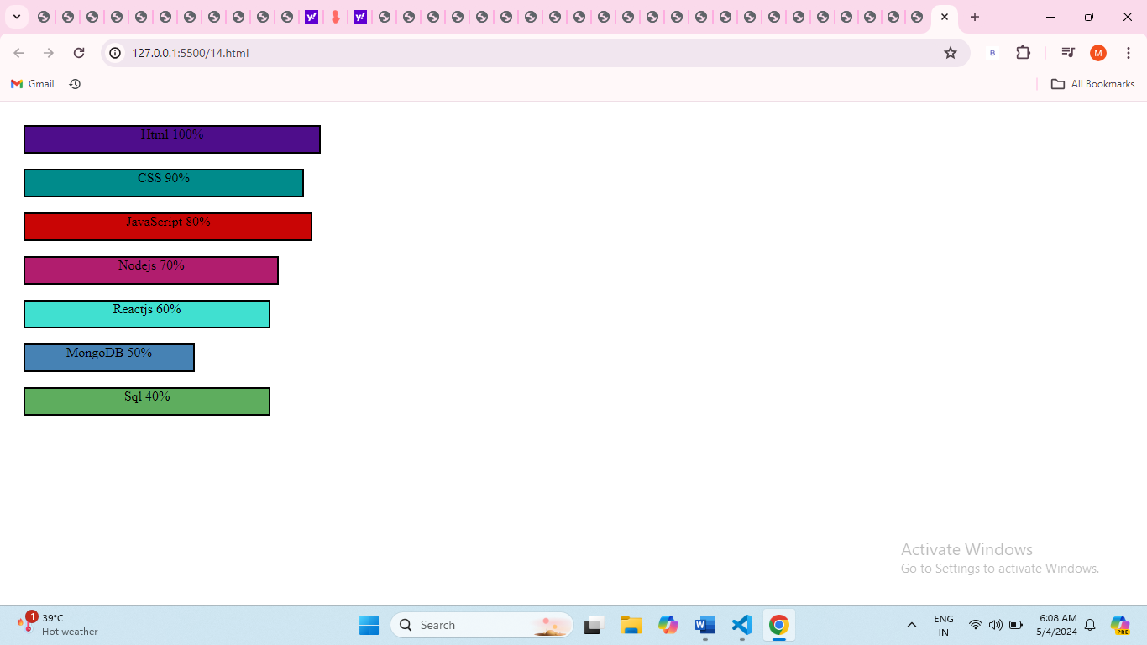

1. Implement a CSS animation on an element, such as a spinning effect.
2. </head>
3. <body>
4. <style>#spin{
5. width: 100px;
6. height: 100px;
7. background-color: rgb(13, 108, 196);
8. animation: spin 1s linear infinite;
9. }
11. @keyframes spin{
12. from{
13. transform: rotate(0deg);
14. }
15. to {
16. transform: rotate(360deg);
17. }
18. }
19. </style>
20. <div id="spin">Hello Everyone</div>
21. </body>
22. </html>

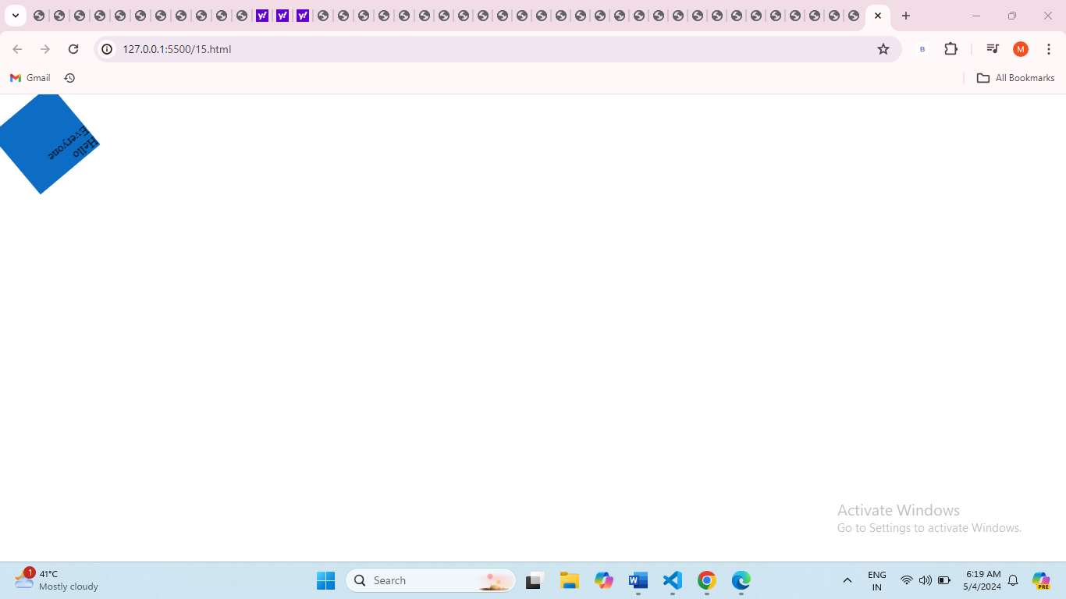

1. Build a tabbed content section using HTML, CSS, and JavaScript.
2. Design a responsive carousel/slider for showcasing images.
3. Style a list to have custom bullet points and spacing between items.
4. <style>
5. #container{
6. display: flex;
7. box-sizing: border-box;
8. justify-content: center;
9. }
10. .list{
11. width: 80px;
12. height: fit-content;
13. border: 1px black solid;
14. border-radius: 4px;
15. }
16. </style>
17. <label >List of items:</label>
18. <div id="list">
19. <ul start="circle">
20. <li class="list" id="l1">pen</li>
21. <li class="list" id="l2">pencil</li>
22. <li class="list" id="l3">eraser</li>
23. <li class="list" id="l4">sharpner</li>
24. <li class="list" id="l5">shoes</li>
25. <li class="list" id="l6">uniform</li>
26. </ul>
27. </div>
28. </div>
29. </body>
30. </html>

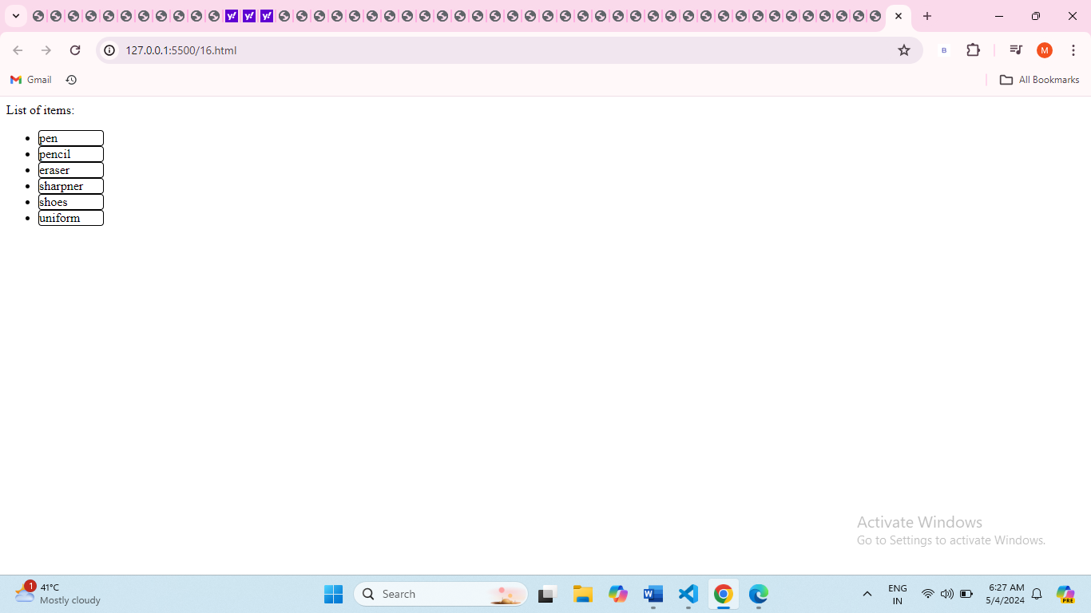

1. Make a website layout that uses a sticky sidebar
2. <body>
3. <style>
4. .nav{
5. height:100%;
6. width: 150px;
7. background-color: rgb(32, 175, 201);
8. position: fixed;
9. z-index: 1;
11. }
12. .nav a{
13. font-size: 30px;
14. color: rgb(45, 45, 197);
15. display: block;
16. padding: 20px;
17. }
18. .nav a:hover{
20. color: darkblue;
21. }
22. </style>
23. <div class="nav">
24. <a href="#about">About</a>
25. <a href="#home">Home</a>
26. <a href="#contact">Contact</a>
27. </div>
29. </body>
30. </html>

. 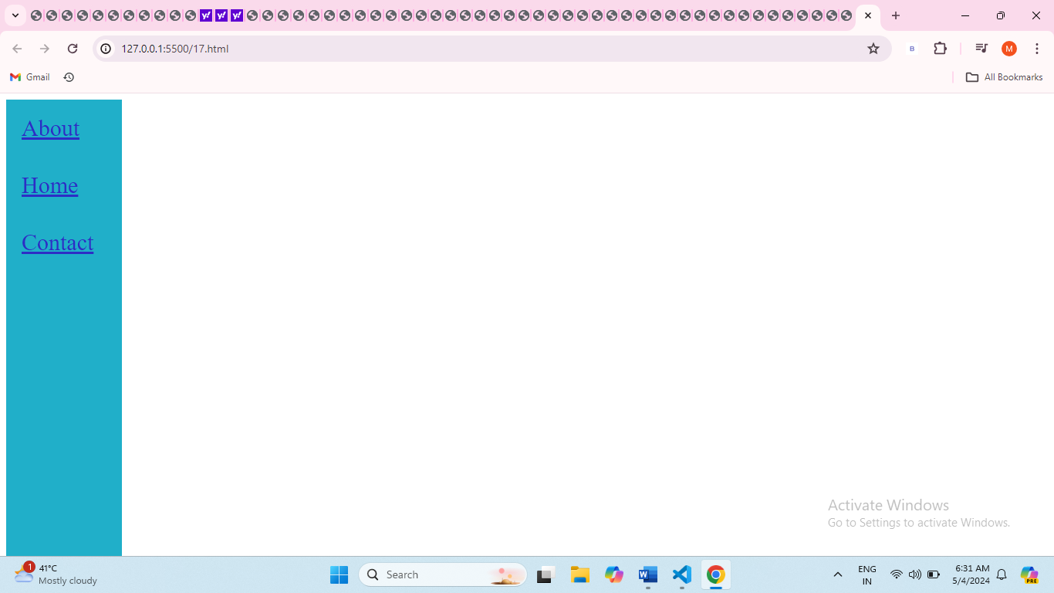

1. Create a simple tooltip using HTML and CSS.
2. <style>
3. /* Tooltip container */
4. .tooltip {
5. position: relative;
6. display: inline-block;
7. border-bottom: 1px dotted black;
8. }
9. .tooltip .tooltiptext {
10. visibility: hidden;
11. width: 120px;
12. background-color: black;
13. color: #fff;
14. text-align: center;
15. padding: 5px 0;
16. border-radius: 6px;
17. position: absolute;
18. z-index: 1;
19. }
20. .tooltip:hover .tooltiptext {
21. visibility: visible;
22. }
23. </style>
24. <div class="tooltip">
25. Clickme
26. <span class="tooltiptext">Hello Everyone</span>
27. </div>

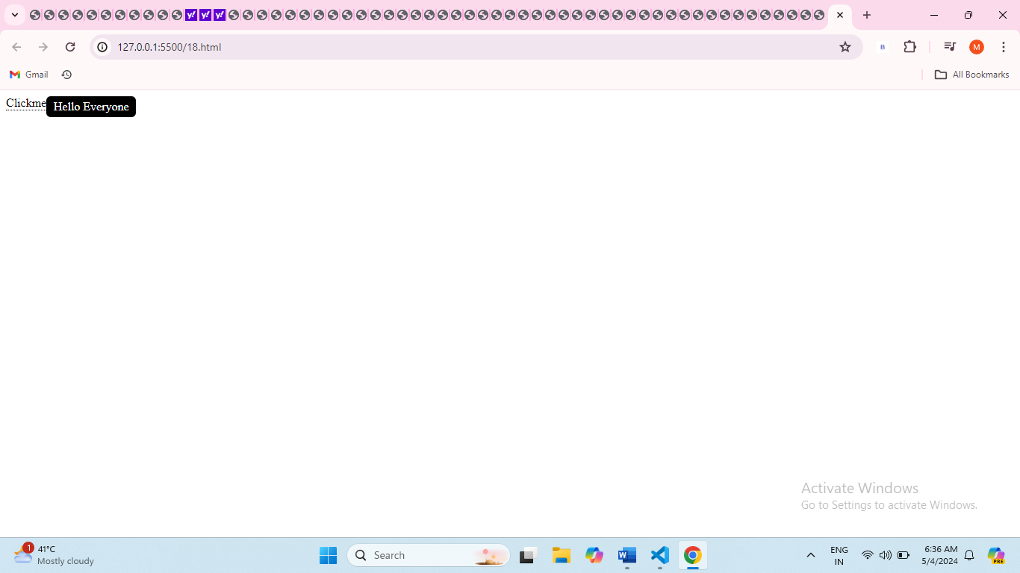

1. Design a card layout for displaying content with an image, title, and description.
2. <!DOCTYPE html>
3. <html lang="en">
4. <head>
5. <meta charset="UTF-8">
6. <meta name="viewport" content="width=device-width, initial-scale=1.0">
7. <style>
8. .card {
9. display: flex;
10. flex-direction: column;
11. align-items: center;
12. padding: 16px;
13. border: 1px solid #ccc;
14. border-radius: 8px;
15. box-shadow: 0 2px 4px rgba(0, 0, 0, 0.1);
16. max-width: 300px;
17. margin: 0 auto;
18. }
19. .card img {
20. max-width: 100%;
21. border-radius: 8px;
22. margin-bottom: 16px;
23. }
24. .card h2 {
25. font-size: 1.5rem;
26. margin-bottom: 8px;
27. }
28. .card p {
29. font-size: 1rem;
30. color: #555;
31. }
32. </style>
33. </head>
34. <body>
35. <div class="card">
36. <img src="https://greemus.com/assets/images/logos/logo4.png" alt="Card Image">
37. <h2>GREEMUS TECHNOLOGY</h2>
38. <p>The greatest challenge in the software development world is to come up with more interactive and high competitive and high quality developments. Greemus software technologies follows a unique process structure that imposed on the software product development Hyderabad.
39. greemus is a customer oriented company offering Mobile applications, Software Development, Web Development , and Business Development technologies in various technologies. For the welfare of its Clients, greemus also additionally steps up for providing Digital promoting, Organic SEO, Ads on Google, Face book, LinkedIn and Various alternative Social Media sites..</p>
40. </div>
41. </body>
42. </html>

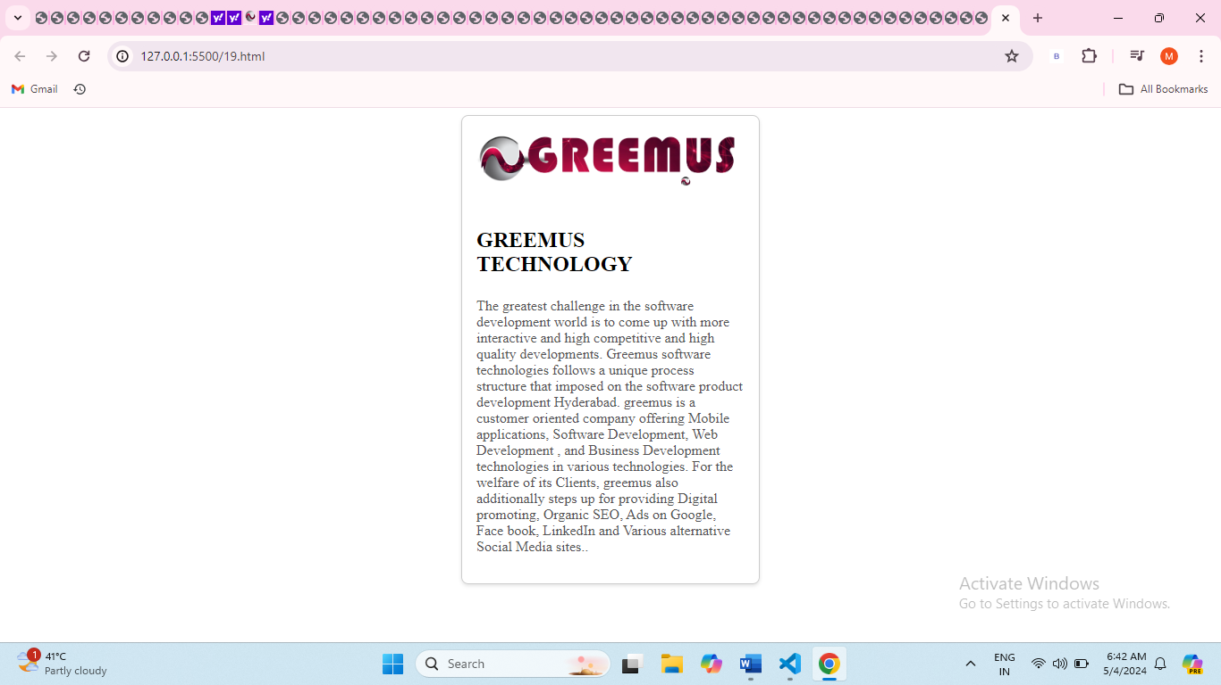

1. Implement a CSS transition on a button to change color smoothly.
2. <style>
4. .color-transition-button {
5. background-color: #3498db;
6. color: #ffffff;
7. padding: 10px 20px;
8. border: none;
9. cursor: pointer;
10. transition: background-color 0.3s ease;
11. }
12. .color-transition-button:hover {
13. background-color: #e74c3c;
14. }
15. </style>
16. <button class="color-transition-button">Click Me</button>

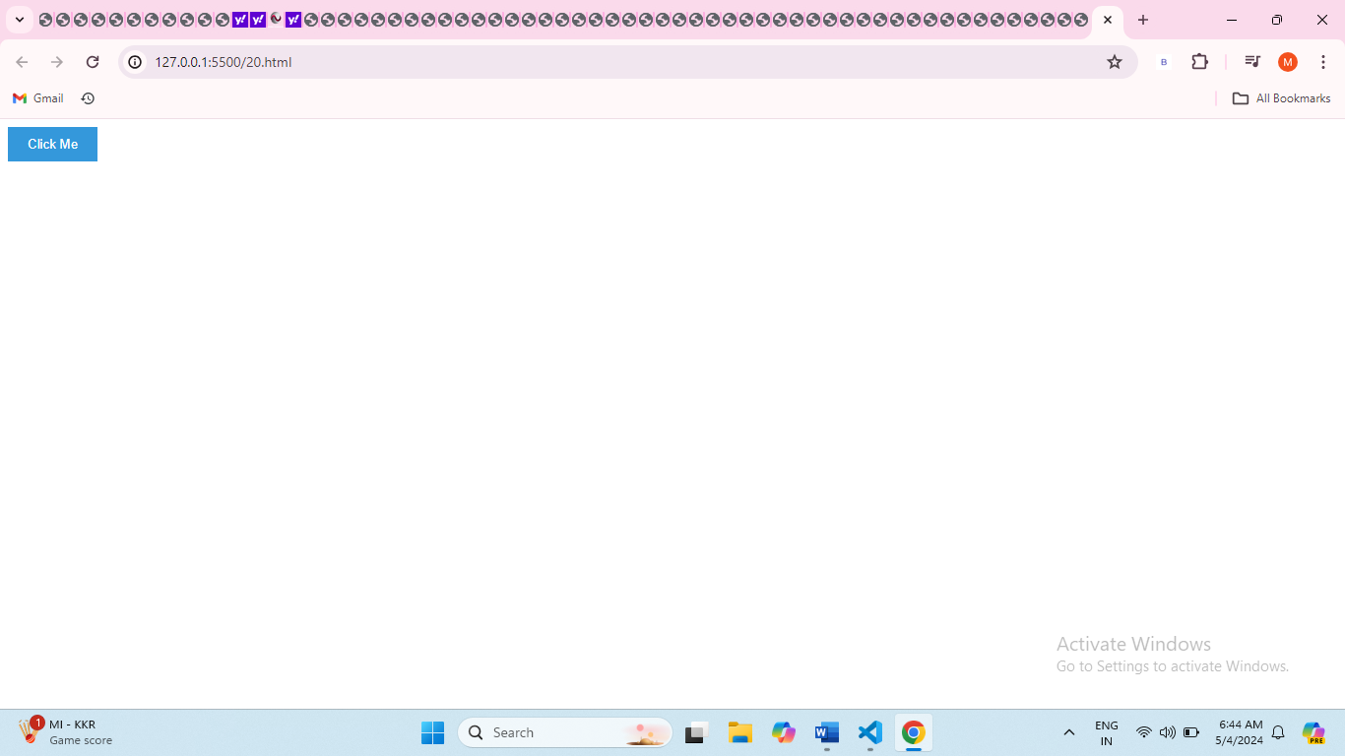

1. Build a responsive navbar with a hamburger menu for mobile devices.
2. <style>
3. * {
4. margin: 0;
5. padding: 0;
6. box-sizing: border-box;
7. }
8. html {
9. font-size: 62.5%;
10. font-family: 'Roboto', sans-serif;
11. }
13. li {
14. list-style: none;
15. }
17. a {
18. text-decoration: none;
19. }
20. .header {
21. border-bottom: 1px solid #E2E8F0;
22. }
24. .navbar {
25. display: flex;
26. justify-content: space-between;
27. align-items: center;
28. padding: 1rem 1.5rem;
29. }
30. .hamburger {
31. display: none;
32. }
34. .bar {
35. display: block;
36. width: 25px;
37. height: 3px;
38. margin: 5px auto;
39. background-color: #101010;
40. transition: all 0.3s ease-in-out;
41. }
42. .nav-menu {
43. display: flex;
44. justify-content: space-between;
45. align-items: center;
46. }
48. .nav-item {
49. margin-left: 5rem;
50. }
52. .nav-link {
53. font-size: 1.6rem;
54. font-weight: 400;
55. color: #475569;
56. }
58. .nav-link:hover {
59. color: #482ff7;
60. }
62. .nav-logo {
63. font-size: 2.1rem;
64. font-weight: 500;
65. color: #482ff7;
66. }
68. @media only screen and (max-width: 768px) {
69. .nav-menu {
70. position: fixed;
71. left: -100%;
72. top: 5rem;
73. flex-direction: column;
74. background-color: #fff;
75. width: 100%;
76. border-radius: 10px;
77. text-align: center;
78. transition: 0.3s;
79. box-shadow: 0 10px 27px rgba(0, 0, 0, 0.05);
80. }
82. .nav-menu.active {
83. left: 0;
84. }
86. .nav-item {
87. margin: 2.5rem 0;
88. }
90. .hamburger {
91. display: block;
92. cursor: pointer;
93. }
94. }
96. </style>
97. <header class="header">
98. <nav class="navbar">
99. <a href="#" class="nav-logo">WebDev.</a>
100. <ul class="nav-menu">
101. <li class="nav-item"><a href="#" class="nav-link">Services</a></li>
102. <li class="nav-item"><a href="#" class="nav-link">Blog</a></li>
103. <li class="nav-item"><a href="#" class="nav-link">About</a></li>
104. <li class="nav-item"><a href="#" class="nav-link">Contact</a></li>
105. </ul>
106. <div class="hamburger">
107. <span class="bar"></span>
108. <span class="bar"></span>
109. <span class="bar"></span>
110. </div>
111. </nav>
112. </header>

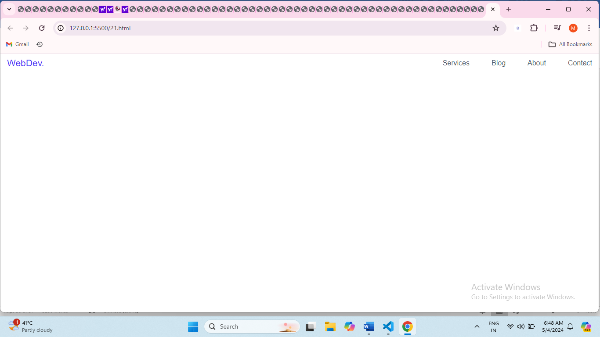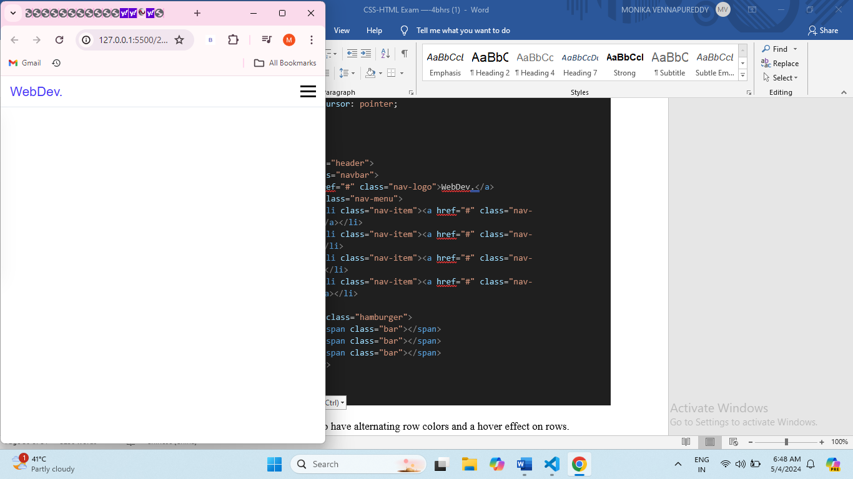

1. Style a table to have alternating row colors and a hover effect on rows.
2. <!DOCTYPE html>
3. <html lang="en">
4. <head>
5. <meta charset="UTF-8">
6. <meta name="viewport" content="width=device-width, initial-scale=1.0">
7. <style>
8. table {
9. width: 100%;
10. border-collapse: collapse;
11. }
12. th, td {
13. padding: 10px;
14. text-align: left;
15. border-bottom: 1px solid #ddd;
16. }
17. tr:nth-child(even) {
18. background-color: #f2f2f2;
19. }
20. tr:hover {
21. background-color: #e6e6e6;
22. }
23. </style>
24. </head>
25. <body>
26. <table>
27. <thead>
28. <tr>
29. <th>Column 1</th>
30. <th>Column 2</th>
31. <th>Column 3</th>
32. </tr>
33. </thead>
34. <tbody>
35. <tr>
36. <td>Data 1</td>
37. <td>Data 2</td>
38. <td>Data 3</td>
39. </tr>
40. <tr>
41. <td>Data 4</td>
42. <td>Data 5</td>
43. <td>Data 6</td>
44. </tr>
45. </tbody>
46. </table>
47. </body>
48. </html>

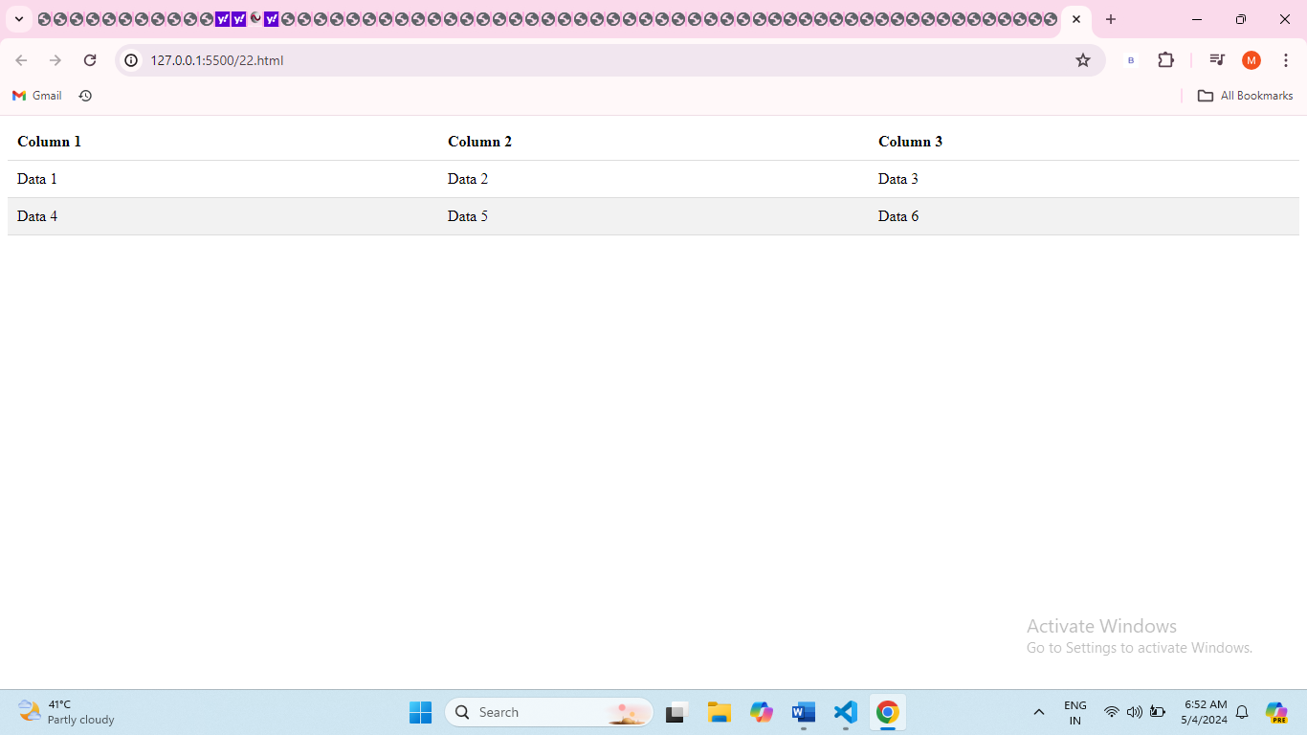

1. Design a progress tracker with steps using HTML and CSS.
2. <body>
3. <style>
5. #parent{
6. padding:10px;
7. margin: 10px;
8. text-align: center;
9. }
10. #d1{
11. width: 350px;
12. height: 30px;
13. border: 2px black solid;
14. background-color: rgb(194, 39, 39);
15. }
16. #d2{
17. width: 330px;
18. height: 30px;
19. border: 2px black solid;
20. background-color: rgb(34, 10, 30);
21. }
22. #d3{
23. width: 200px;
24. height: 30px;
25. border: 2px black solid;
26. background-color: hotpink;
27. }
28. #d4{
29. width: 300px;
30. height: 30px;
31. border: 2px black solid;
32. background-color:rgb(176, 121, 121);
33. }
34. </style>
35. <div id="container">
36. <div id="parent" >
37. <div id="d1"></div><br>
38. <div id="d2"></div><br>
39. <div id="d3"></div><br>
40. <div id="d4"></div><br>
41. <div>
42. </div>
43. </div>
44. </div>
46. </body>
47. </html>
48. </body>
49. </html>

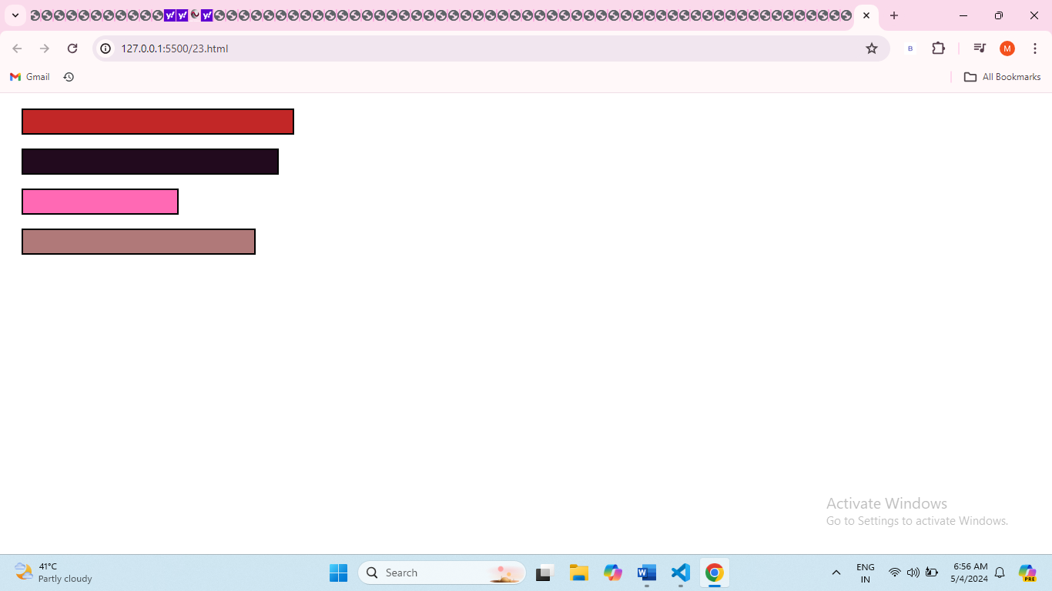

1. Create a parallax scrolling effect on a webpage background.
2. <!DOCTYPE html>
3. <html lang="en">
4. <head>
5. <meta charset="UTF-8">
6. <meta name="viewport" content="width=device-width, initial-scale=1.0">
7. <title>Parallax Scrolling Example</title>
8. </head>
9. <body>
10. <style>
11. body, html {
12. height: 100%;
13. margin: 0;
14. font-family: Arial, sans-serif;
15. }
16. .parallax {
17. min-height: 100vh;
18. background-image: url("https://tse1.mm.bing.net/th?id=OIP.QTMD-mnaS9ASLfczUreLrQHaCQ&pid=Api&P=0&h=220");
19. background-attachment: fixed;
20. background-position: center;
21. background-repeat: no-repeat;
22. background-size: cover;
23. color: #080000d0;
24. text-align: center;
25. padding: 100px 0;
26. }
27. h1 {
28. font-size: 3rem;
29. margin-bottom: 20px;
30. }
31. p {
32. font-size: 1.5rem;
33. }
34. </style>
35. <div class="parallax">
36. <h1>Welcome to GREEMUS</h1>
37. <p>The greatest challenge in the software development world is to come up with more interactive and high competitive and high quality developments. Greemus software technologies follows a unique process structure that imposed on the software product development Hyderabad.
38. greemus is a customer oriented company offering Mobile applications, Software Development, Web Development , and Business Development technologies in various technologies. For the welfare of its Clients, greemus also additionally steps up for providing Digital promoting, Organic SEO, Ads on Google, Face book, LinkedIn and Various alternative Social Media sites.
40. </p>
41. </div>
42. </body>
43. </html>



1. Build a dropdown select menu with options styled using CSS
2. <!DOCTYPE html>
3. <html lang="en">
4. <head>
5. <meta charset="UTF-8">
6. <meta name="viewport" content="width=device-width, initial-scale=1.0">
7. <title>Custom Dropdown Select Menu</title>
8. </head>
9. <body>
10. <style>
11. body{
12. padding: 20px;
13. text-align: center;
14. box-sizing: border-box;
15. background-color: rgb(185, 144, 172);
16. border: 2px black solid;
17. height: 300px;
18. width: 300px;
19. }
20. #o{
21. background-color: darkseagreen;
22. }
23. #r{
24. background-color:cornflowerblue;
25. }
26. #p{
27. background-color:darkseagreen;
28. }
29. #a{
30. background-color:indianred;
31. }
32. #s{
33. background-color:rgb(162, 18, 66);
34. }
35. #j{
36. background-color:cornflowerblue;
37. }
38. </style>
39. <div class="custom-select">
40. <select>
41. <option value="0">Select a fruit:</option>
42. <option value="1">Apple</option>
43. <option value="2">Banana</option>
44. <option value="3">Orange</option>
46. </select>
47. </div>
48. </body>
49. </html>

